🧪 Chemistry Jokes 🧪
20 Curriculum-Linked Jokes
Each joke connects to a key learning point

Contents
1. What do you do with a sick chemist? [Elements: Helium, Curium, Barium]
2. Why do chemists like nitrates? [Nitrate compounds (NO₃⁻)]
3. What element is a girl's best friend? [Carbon allotropes: diamond, graphite]
4. Why did the noble gas cry? [Noble gases are unreactive (Group 0)]
5. What did the scientist say when they discovered oxygen and potassium? [Chemical symbols: O and K]
6. Why did carbon and hydrogen break up? [Chemical bonding between elements]
7. Why is the periodic table always ready? [The periodic table organises elements]
8. Old chemists never die... [Chemical reactions]
9. What do you call iron blowing in the wind? [Iron's chemical symbol is Fe]
10. Why are chemists great at solving problems? [Solutions — solute dissolved in solvent]
11. What did one ion say to another? [Ions are charged atoms]
12. What's the most important chemistry rule? [Lab safety procedures]
13. Why did the acid go to the gym? [Buffer solutions resist pH changes]
14. What kind of fish is made of only two sodium atoms? [Sodium's chemical symbol is Na]
15. How did the chemist survive the famine? [Titration measures concentration]
16. Why do white bears dissolve in water? [Polar molecules dissolve in water]
17. What do you call a tooth in a glass of water? [Molarity — concentration measure]
18. Why was the mole of oxygen molecules excited? [Avogadro's number: 6.022×10²³]
19. What's the chemical formula for a banana? [Chemical formulae and subscripts]
20. Why can't you trust an atom? [Atoms compose all matter]

Joke #1
📌 Curriculum Link: Elements: Helium, Curium, Barium

Q: What do you do with a sick chemist?
A: If you can't helium and you can't curium, you barium!
💡 Discussion: Why is this joke funny? What does it tell us about "Elements: Helium, Curium, Barium"? Can you explain the concept to a partner?

Joke #2
📌 Curriculum Link: Nitrate compounds (NO₃⁻)
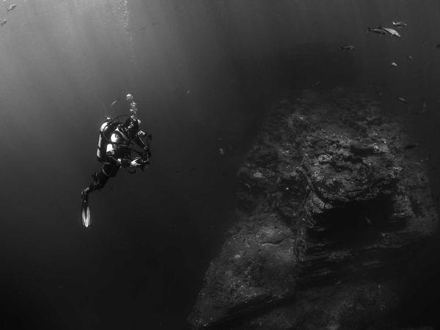
Q: Why do chemists like nitrates?
A: Because they're cheaper than day rates!
💡 Discussion: Why is this joke funny? What does it tell us about "Nitrate compounds (NO₃⁻)"? Can you explain the concept to a partner?

Joke #3
📌 Curriculum Link: Carbon allotropes: diamond, graphite
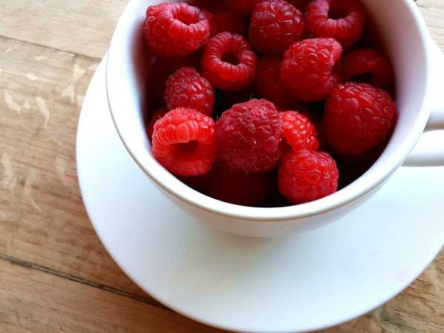
Q: What element is a girl's best friend?
A: Carbon — it makes diamonds!
💡 Discussion: Why is this joke funny? What does it tell us about "Carbon allotropes: diamond, graphite"? Can you explain the concept to a partner?

Joke #4
📌 Curriculum Link: Noble gases are unreactive (Group 0)

Q: Why did the noble gas cry?
A: Because all its friends argon!
💡 Discussion: Why is this joke funny? What does it tell us about "Noble gases are unreactive (Group 0)"? Can you explain the concept to a partner?

Joke #5
📌 Curriculum Link: Chemical symbols: O and K

Q: What did the scientist say when they discovered oxygen and potassium?
A: OK!
💡 Discussion: Why is this joke funny? What does it tell us about "Chemical symbols: O and K"? Can you explain the concept to a partner?

Joke #6
📌 Curriculum Link: Chemical bonding between elements

Q: Why did carbon and hydrogen break up?
A: They just had no chemistry!
💡 Discussion: Why is this joke funny? What does it tell us about "Chemical bonding between elements"? Can you explain the concept to a partner?

Joke #7
📌 Curriculum Link: The periodic table organises elements

Q: Why is the periodic table always ready?
A: Because it's full of elements of surprise!
💡 Discussion: Why is this joke funny? What does it tell us about "The periodic table organises elements"? Can you explain the concept to a partner?

Joke #8
📌 Curriculum Link: Chemical reactions

Q: Old chemists never die...
A: They just stop reacting!
💡 Discussion: Why is this joke funny? What does it tell us about "Chemical reactions"? Can you explain the concept to a partner?

Joke #9
📌 Curriculum Link: Iron's chemical symbol is Fe

Q: What do you call iron blowing in the wind?
A: FeBreeze! (Fe = Iron)
💡 Discussion: Why is this joke funny? What does it tell us about "Iron's chemical symbol is Fe"? Can you explain the concept to a partner?

Joke #10
📌 Curriculum Link: Solutions — solute dissolved in solvent

Q: Why are chemists great at solving problems?
A: Because they have all the solutions!
💡 Discussion: Why is this joke funny? What does it tell us about "Solutions — solute dissolved in solvent"? Can you explain the concept to a partner?

Joke #11
📌 Curriculum Link: Ions are charged atoms

Q: What did one ion say to another?
A: I've got my ion you!
💡 Discussion: Why is this joke funny? What does it tell us about "Ions are charged atoms"? Can you explain the concept to a partner?

Joke #12
📌 Curriculum Link: Lab safety procedures

Q: What's the most important chemistry rule?
A: Never lick the spoon!
💡 Discussion: Why is this joke funny? What does it tell us about "Lab safety procedures"? Can you explain the concept to a partner?

Joke #13
📌 Curriculum Link: Buffer solutions resist pH changes

Q: Why did the acid go to the gym?
A: To become a buffer solution!
💡 Discussion: Why is this joke funny? What does it tell us about "Buffer solutions resist pH changes"? Can you explain the concept to a partner?

Joke #14
📌 Curriculum Link: Sodium's chemical symbol is Na

Q: What kind of fish is made of only two sodium atoms?
A: 2 Na! (Tuna)
💡 Discussion: Why is this joke funny? What does it tell us about "Sodium's chemical symbol is Na"? Can you explain the concept to a partner?

Joke #15
📌 Curriculum Link: Titration measures concentration

Q: How did the chemist survive the famine?
A: By subsisting on titrations!
💡 Discussion: Why is this joke funny? What does it tell us about "Titration measures concentration"? Can you explain the concept to a partner?

Joke #16
📌 Curriculum Link: Polar molecules dissolve in water

Q: Why do white bears dissolve in water?
A: Because they're polar!
💡 Discussion: Why is this joke funny? What does it tell us about "Polar molecules dissolve in water"? Can you explain the concept to a partner?

Joke #17
📌 Curriculum Link: Molarity — concentration measure

Q: What do you call a tooth in a glass of water?
A: A one molar solution!
💡 Discussion: Why is this joke funny? What does it tell us about "Molarity — concentration measure"? Can you explain the concept to a partner?

Joke #18
📌 Curriculum Link: Avogadro's number: 6.022×10²³

Q: Why was the mole of oxygen molecules excited?
A: It was going to a party at Avogadro's!
💡 Discussion: Why is this joke funny? What does it tell us about "Avogadro's number: 6.022×10²³"? Can you explain the concept to a partner?

Joke #19
📌 Curriculum Link: Chemical formulae and subscripts

Q: What's the chemical formula for a banana?
A: BaNa₂!
💡 Discussion: Why is this joke funny? What does it tell us about "Chemical formulae and subscripts"? Can you explain the concept to a partner?

Joke #20
📌 Curriculum Link: Atoms compose all matter

Q: Why can't you trust an atom?
A: Because they make up literally everything!
💡 Discussion: Why is this joke funny? What does it tell us about "Atoms compose all matter"? Can you explain the concept to a partner?

